Pokhara University

Level: Bachelor | Semester – Fall | Year : 2010
Programme: BE |  | Full Marks: 100
Course: Signal System and Processing |  | Pass Marks: 45
 |  | Time : 3hrs.

Candidates are required to give their answers in their own words as far as practicable.
The figures in the margin indicate full marks.

Attempt all the questions.

 | - Write down the conditions for the existence of the Fourier Transform. Find the Fourier Transform of a given function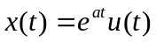.  - Determine whether or not the given signal 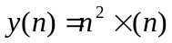is  - Linear  - Causal  - Stable  - Shift Invariant | 7  8
 | - Draw the magnitude response of Butterworth, Chebyshev I & Chebyshev II filter and hence compare them.  - The following specification are given for low pass filter rad/sec.  Calculate the order of Butterworth filter and determine the location of poles and T(s). Also calculate the order of Chebyshev I filter. Which would you select? | 7  8
 | - Define z-transform and ROC. Determine z-transform and ROC of the signal 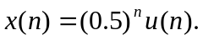  - Realize the direct form I and Direct form II structure. Also draw signal flow graph of Direct Form II structure. | 7  8
 | - Define circular convolution. Also computer circular convolution of the given sequence  - Explain about Gibb's phenomena. Also explain about its remedy. | 8  7
 | - What is matched Z-transform? Obtain the H(Z) (digital response) using Impulse Invariant technique for an analog system given as: 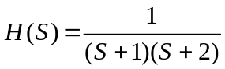  - Explain bilinear transformation with its advantages and disadvantages. | 8  7
 | - Design low pass discrete time filter by applying impulse invariance to an approximate Butterworth continious filter if the passband frequency is 0.4Π radian and maximum deviation of 1 dB below 0 dB gain in passband. The maximum gain of -40 dB and frequency is 0.6Π radian in stopband. Consider the sampling time period as 1 sec.  - What is the main advantage of direct form-II structure over direct form –I structure of IIR filter? Realize the system with the difference equation in cascade form. | 7  8
 | Write short notes on: (Any Two)  - Radix-2 FFT algorithm  - Noise in digital filter  - Energy and Power signal | 2×5

